SpotLight

* Making Conversations stay Focused

*Project report submitted to the Amrita Vishwa Vidyapeetham in partial fulfilment of the requirement for the Degree of*

**BACHELOR of TECHNOLOGY**

**in**

**COMPUTER SCIENCE AND ENGINEERING**

*Submitted by*

**CH.Mounish AM.EN.U4CSE18113**

**Kallam Subhash Reddy AM.EN.U4CSE18126**

**Likith Mothukuri AM.EN.U4CSE18136**

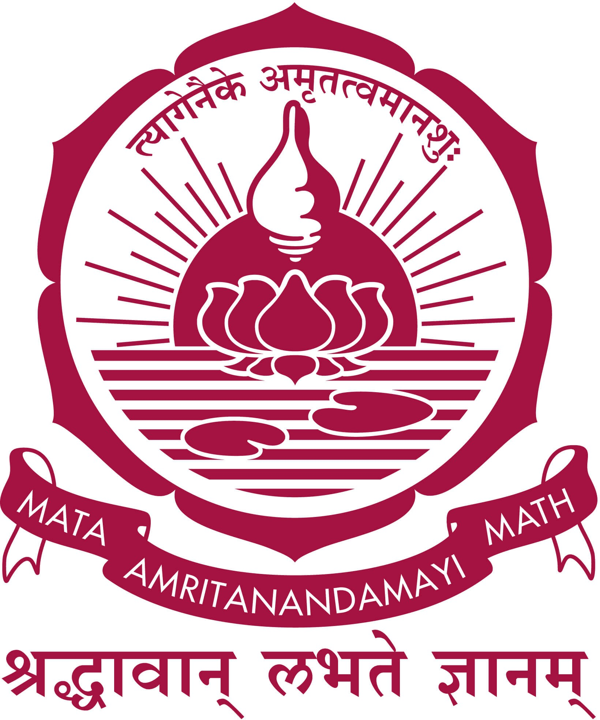**Vijay Tanmay Tatikonda AM.EN.U4CSE18155**

**AMRITA SCHOOL OF ENGINEERING**

**AMRITA VISHWA VIDYAPEETHAM**

**(Estd. U/S 3 of the UGC Act 1956) AMRITAPURI CAMPUS**

**KOLLAM -690525**

# MAY 2021

**DEPARTMENT OF COMPUTER SCIENCE AND ENGINEERING**

**AMRITA VISHWA VIDYAPEETHAM**

**(Estd. U/S 3 of the UGC Act 1956) Amritapuri Campus**

**Kollam -690525**



# BONAFIDE CERTIFICATE

This is to certify that the project report entitled **“SpotLight”** submitted by **Ch. Mounish (AM.EN.U4CSE18113), Kallam Subhash Reddy (AM.EN.U4CSE18126), Likith Mothukuri (AM.EN.U4CSE18136) and Vijay Tanmay Tatikonda (AM.EN.U4CSE18155)**, in partial fulfillment of the requirements for the award of Degree of Bache- lor of Technology in Computer Science and Engineering from Amrita Vishwa Vidyapeetham, is a bonafide record of the work carried out by them under my guidance and supervision at Amrita School of Engineering, Amritapuri during Semester 8 of the academic year 2020-2021.

Vinitha J Panicker Pratibha Mol CP

Project Guide Project Coordinator

Dr. Prema Nedungadi Reviewer

Chairperson

Dept. of Computer Science & Engineering

Place : Amritapuri Date : 22 Dec 2021

**DEPARTMENT OF COMPUTER SCIENCE & ENGINEERING**

**AMRITA VISHWA VIDYAPEETHAM**

**(Estd. U/S 3 of the UGC Act 1956) Amritapuri Campus**

**Kollam -690525**



# DECLARATION

We, **Ch. Mounish (AM.EN.U4CSE18113), Kallam Subhash Reddy (AM.EN.U4CSE18126), Likith Mothukuri (AM.EN.U4CSE18136) and Vijay Tanmay Tatikonda (AM.EN.U4CSE18155)**, hereby declare that this project entitled **“SpotLight”** is a record of the original work done by us under the guidance of **Vinitha J Panicker**, Dept. of Computer Science and Engineering, Amrita Vishwa Vidyapeetham, that this work has not formed the basis for any degree/diploma/associationship/fellowship or similar awards to any candidate in any university to the best of our knowledge.

Place : Amritapuri Date : 22 Dec 2021

Signature of the student Signature of the Project Guide

**Acknowledgements**